ARMS

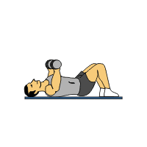

**Flat Chest Presses**

1.Lying flat on bench, hold the dumbbells directly above chest, arms extended.

2.Lower dumbbells to chest in a controlled manner.

3.Press dumbbells back to starting position and repeat.

4.Avoid locking elbows

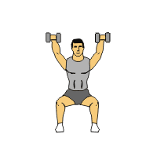

**Seated Shoulder Presses**

1. Sit upright on bench with dumbbells over head. Make sure back is flat.

2. Lower dumbbells slowly to shoulders.

3. When arms are at 90 degrees, press the dumbbells back up and repeat.

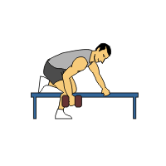

**Single Arm Row**

1. Stand upright next to bench. Place one knee and hand on bench. Upper body should be parallel to floor.

2. Hold one dumbbell with arm extended.

3. Raise dumbbell up to your midsection keeping back still throughout movement.

4. Slowly lower dumbbell to start position and repeat. After desired number of reps repeat for other arm.

LEGS

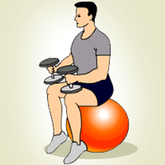

**Seated Calf Raises**

1. Sit on the edge of the bench, feet flat on the floor about 12 inches apart.

2. Rest dumbells on thighs while keeping hold of them.

3. While staying seated raise heels by just using toes.

4. Lower your heels to the ground and repeat.

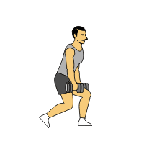

**Dumbbell Lunges**

1. Holding dumbbells at sides, stand upright with feet slightly less than shoulder width apart.

2. Step forward about 2 feet with one foot and bend knee to about 90 degrees. As you plant your foot bend trailing knee so it nearly touches floor.

3. Push off with front foot to return to starting position.

4. Repeat for the desired number of reps and change legs.

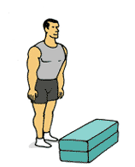

**Jump to Box**

1. Stand facing box with feet slightly wider than hip-width apart.

1. Lower body into a semi-squat position and immediately jump up onto box. Do not hold a squat position before jumping up keep the time between dipping down and jumping up to a minimum.

3. Feet should land softly on box. Step back down (not jump back down) and repeat.

CORE

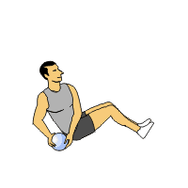

**Seated Russian Twists**

1. Sitting down suspend your feet off of the ground.

2. Holding a medicine ball rotate your shoulders side to side touching the medicine ball to the ground. Keep feet off floor

3. Repeat for the prescribed number of repetitions.

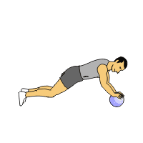

**Medicine Ball Plank**

1. On your knees and place hands on a medicine ball.

2. Start position: Align hands at nipple line, place feet hip width apart on toes, and extend the arms to raise body up. Trunk and hips should be in a straight line.

3. Hold for 10 seconds. This is one set. Gradually build up to 30 seconds plus.

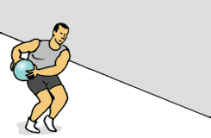

**Side Throws**

1. Stand with feet hip-width apart; place left foot approximately one foot in front of right foot.

2. Hold medicine ball with both hands and arms only slightly bent.

3. Swing ball over to the right hip and forcefully underhand toss ball forward to a partner or wall. Keep the stomach drawn in to maximize proper usage of muscle.

4. Catch ball on the bounce from your partner or wall and repeat according to prescribed repetitions.

CARDIO

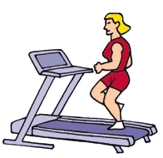

**Treadmill**

1. Start by placing the speed at a comfortable walk. If you want, increase the speed until you are into a jog or run.

2. You can also place the treadmill on an incline to increase the difficulty.

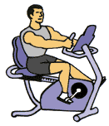

**Recumbent Bike**

1. Sit in the seat and adjust the seat so that your knee is slightly bent when the pedal is in the

farthest position.

2. Adjust the resistance so that it is challenging yet allows you to keep good technique.

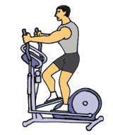

**Elliptical**

1. Place your feet on the foot plates and grab the arm handles.

2. Set your resistance so that it is challenging and start the elliptical motion by pulling machine arm with one arm and push the other machine arm.

3. Pick a pace that will elevate your heart rate yet let you stay on the machine for a while.